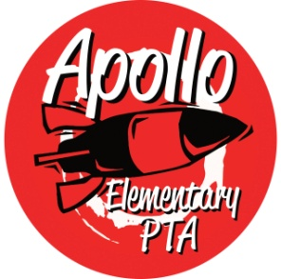**Apollo Elementary PTA**

**15025 SE 117th Street Renton, WA 98059**

**Apollo PTA Mission Statement**

The Apollo Elementary Parent Teacher Association (PTA) is a non-profit, volunteer organization dedicated to enhancing the educational and social experiences of all Apollo students. We do this by:

* Being a powerful voice for children
* Bringing together parents, teachers, students and community members
* Providing curriculum enhancement opportunities for every student
* Building a strong, welcoming, and healthy school environment

**Apollo PTA Goals**

* The PTA shall remain a PTA in good standing by adhering to National and State PTA Best Practices and local, state and federal laws. Per the Washington State PTA Uniform Bylaws, shall annually review, complete, sign, and submit the WSPTA Standards of Affiliation agreement by the required deadline.
* The PTA will clearly brand all PTA events and communications to raise awareness of PTA programming and activities.
* The PTA will conduct purposeful fundraising, with an annually determined goal, to fully fund the Apollo PTA budget.
* The PTA will host a minimum of 6 PTA events and programs combining education and enrichment that create opportunities to foster social connections and cultural awareness.
* The PTA will promote, attain and support 100% membership.
* The PTA will involve and encourage greater parental support by providing a variety of opportunities to volunteer.
* The PTA will offer grant funds, as determined annually during the budget process, to support school and curriculum-based activities.
* The PTA will participate in at least 2 charitable projects benefitting the community.
* The PTA will advocate for our school at the local and state level through support for levies and bond measures, and updates about important education issues.